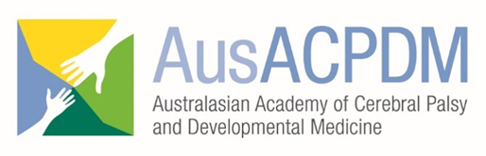

AusACPDM CONFERENCE SCHOLARSHIP APPLICATION FORM
10th Biennial Scientific Conference
11-14 March 2020, Perth, Western Australia
(FOR AUSTRALASIAN & INTERNATIONAL SCHOLARSHIPS)

CLOSING DATE: Midnight AEST - 31st October 2019

To be eligible to receive a conference scholarship for the 2020 AusACPDM conference, candidates must upload the following documents separately as instructed on the AusACPDM website:

- Signed application form (this form, which is self-nominated) - nominations by other parties will not be accepted
- Proof of current AusACPDM membership
  - please visit www.ausacpdm.org.au/membership to apply for membership
- Demonstrated need according to:
  - International Applicants - residency in a non-OECD country
  - All applicants - a statement from your institution stating that other possible sources of funding have been applied for and institutional funding is not available. Self-employed candidates may provide their own statement of need
- A recent photo to assist with mentor recognition should you be successful in your application
- Completed recommendation form

- Candidate details
Name
Discipline
Affiliation/s
Email address
Postal address
Telephone number/s
Scholarship type | Select one:  Australian / New Zealand  OR  International

- Details of Funding sought
Item | Description | Cost (in AUD)
Travel
Accommodation | Number of nights =
Conference registration fees
Other items may be considered
subject to available funding

- Reason for scholarship
3a. How will your participation in the AusACPDM conference enhance your own knowledge and/or skills? (max 150 words)
Cut/paste/type freely into this box
3b. How will you share the knowledge and skills that you gain with your colleagues in your own community / state / country? (max 150 words)
Cut/paste/type freely into this box
3c. How will the knowledge/skills enhance service provision in your own community / state / country? (max 150 words)
Cut/paste/type freely into this box
3c. How will the knowledge/skills enhance outcomes for clients and families in your own community / state / country? (max 150 words)
Cut/paste/type freely into this box

- Candidate self-nomination agreement
By signing this nomination, I agree to:
- Have my name published in the conference app as a scholarship recipient
- Have my name published on the AusACPDM website as a scholarship recipient
- Provide a written report (300 words) within 2 months of attending the conference on how my attendance at the conference has enhanced my knowledge, skills and service delivery.
Signature: Date: DD / MM / YYYY

Submission Instructions:
Please upload documents as instructed on the AusACPDM webpage entitled: Scholarship Application Submission.
Nominations close midnight AEST - 31st October 2019.
Late nominations will not be accepted.

