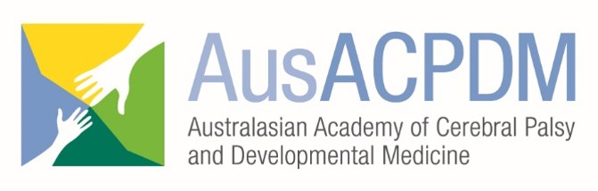

AusACPDM Conference Scholarship Program
Recommendation Form
The Board of Directors of the Australian Academy of Cerebral Palsy and Developmental Medicine (AusACPDM) is committed to making the Biennial Conference accessible to persons from resource poor communities or workplaces, or where attendance at the conference would not be possible without additional funding support.
Therefore, the AusACPDM is offering Scholarships for Australasian (Australia/NZ) and International (Non-OECD countries*) attendees. Applicants are asked to upload this recommendation form as completed by their employer or student body, which includes but is not limited to the applicant’s area of work in childhood disability, capacity to speak and understand English, how the applicant will benefit from the conference and how the applicant will disseminate the knowledge on return home.
Please upload this form as instructed on the AusACPDM Scholarship Application Submission webpage by 31st October 2019

SECTION 1 - TO BE COMPLETED BY APPLICANT
NAME OF APPLICANT
APPLICANT’S ROLE & ORGANISATION
SUBMITTED ABSTRACT TITLE/S, if applicable

SECTION 2 – TO BE COMPLETED BY AN EMPLOYER, SUPERVISOR OR ACADEMIC INSTRUCTOR WHO HAS WORKED WITH THE APPLICANT

NAME
TITLE & POSITION
INSTITUTION
EMAIL ADDRESS
SIGNATURE |  | DATE

1. In what capacity and how long have you known the applicant?
Student Supervisor
Trainee Supervisor
Clinical Colleague
Academic Colleague
Other Please specify__________________________________________________

2. In what way would attending this meeting contribute to the applicant’s academic or professional development?

3. How will the applicant disseminate knowledge gained at the conference to their organisation or network?

4. How would you rate the applicant in the following areas? If you are unable to evaluate an area please leave it blank.

Excellent Very Good Average Below Average
Clinical knowledge
Academic knowledge
Leadership
Initiative
Seriousness of purpose
Adaptability
Maturity
Teaching ability
Research generation

5. Please rate the applicant’s present English language capability as you know it.

Superior Good Fair Basic
Reading
Writing
Comprehension
Speaking

6. Additional comments:

